Lab 8 – Inter-VLAN Routing LAB

1. Topology

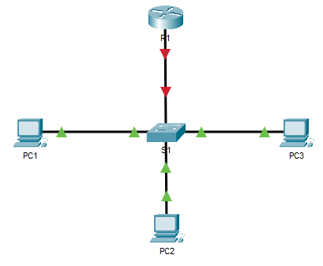

1. Addressing Table

|  |  |  |  |  |
| --- | --- | --- | --- | --- |
| Device | Interface | IPv4 Address | Subnet Mask | Default Gateway |
| R1 | G0/0.10 | 172.17.10.1 | 255.255.255.0 | N/A |
| G0/0.30 | 172.17.30.1 | 255.255.255.0 | N/A |
| PC1 | NIC | 10.10.10.1 | 255.255.255.0 | 10.10.10.254 |
| PC2 | NIC | 20.20.20.1 | 255.255.255.0 | 20.20.20.254 |
| PC3 | NIC | 30.30.30.1 | 255.255.255.0 | 30.30.30.254 |

1. Test Connectivity Without Inter-VLAN Routing
   1. Ping between PC1 and PC3.

From PC1, ping to PC2 and PC3. The pings should fail

Why ? ____________________________________The PCs are in different networks and there’s no routing therefore, they cannot communicate with each other. __________________________________________

1. Configure Subinterfaces
   1. Configure subinterfaces on R1 using the 802.1Q encapsulation.
   2. Verify Configuration.
      1. Use the **show ip interface brief** command to verify subinterface configuration. Ensure that the subinterfaces are in an active state
2. Enable Trunking
   * 1. Because the router was configured with multiple subinterfaces assigned to different VLANs, the switch port connecting to the router must be configured as a trunk. Enable trunking on the appropriate interface.
     2. How can you determine that the interface is a trunk port?

__________________The interface that connects moves traffic from different vlans on the switch__________________________________________________________________

1. Test Connectivity with Inter-VLAN Routing
   1. Ping between PC1, PC2, and PC3.

From **PC1**, ping **PC3**. The pings should pass

